Network Faxing with Exchange
- Setup modem on Network Fax Server
- Run Windows Messaging

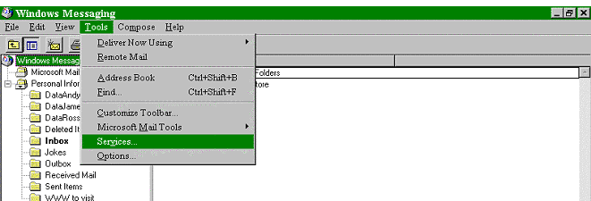
- From the Tools Menu, choose Services

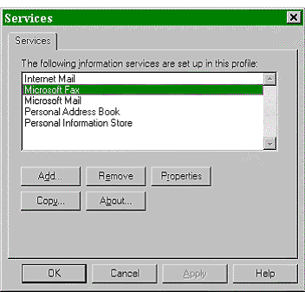

4. Click on Add and choose Microsoft Fax
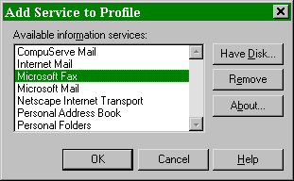
- Click on Properties and enter User Information by Choosing User Tab
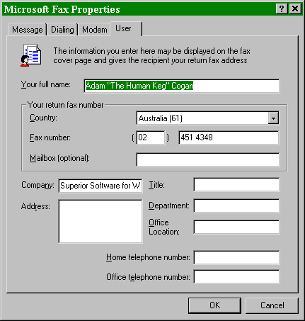
- Enter Modem Information by choosing Modem Tab
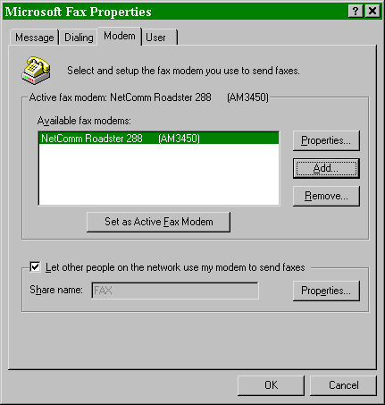
- Click on Let other people on the network use my modem to send faxes
- Click on Properties next to Share Name and enter the Share Name and Access Type
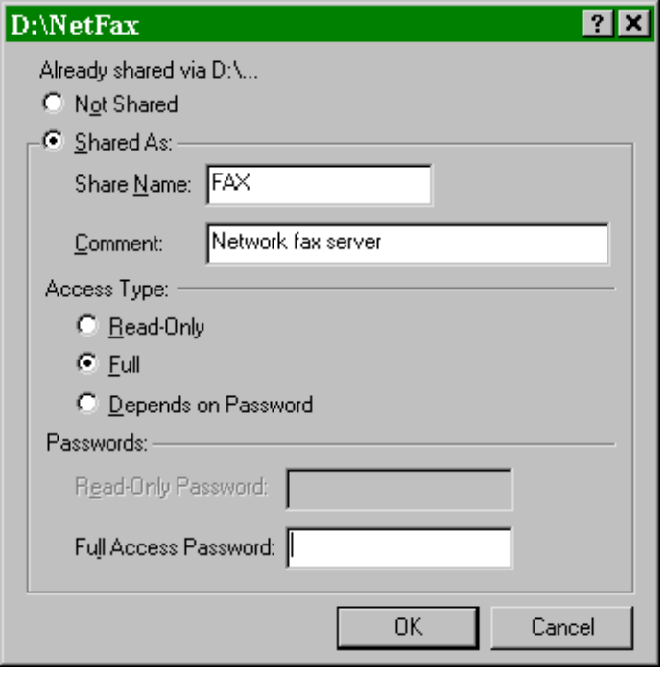
- To add a Modem, from the Microsoft Fax Properties choose Modem tab and click on Add
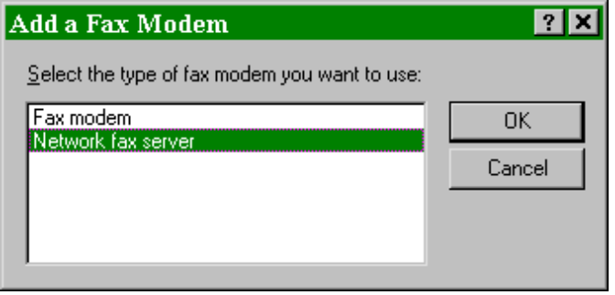
- Choose Network Fax Server
- Path is \\<ServerName\FaxName ie \\Pentium100\FaxModem
